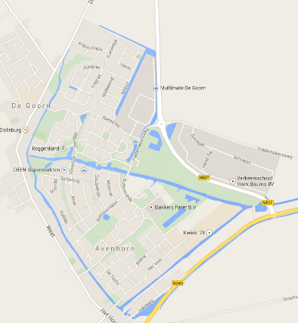
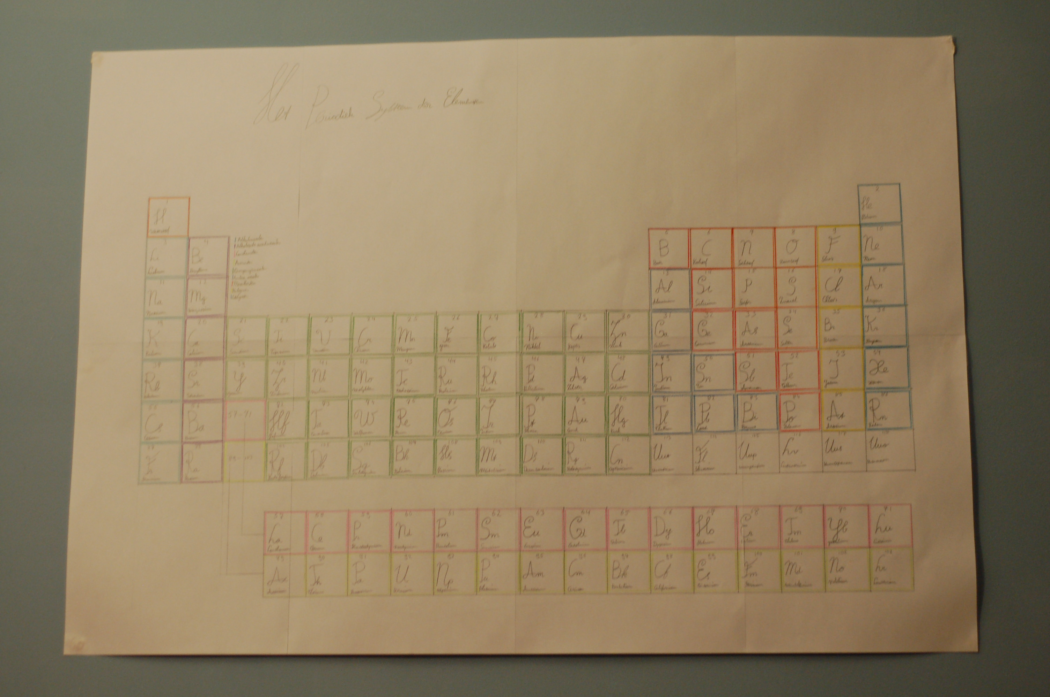My name is Robin Wacanno and I’m 15 years old. I live in an average sized town called De Goorn. This town is situated 10 to 12 kilometres from my school. Luckily this is not very far so I usually cycle to school. I’m currently in the 4th grade of secondary education which in some overseas territories (US and Canada) is called 10th grade. The class I’m currently in is quite nice. I can get along quite well with most of my classmates. This year however the group of friend I had built up in former years was spread out over a number of different classes which does kind of sucks. As I said, the town I live in is averagely sized. It has however in recent years been constantly growing. Despite of this it is still very boring to love there. The only vaguely interesting place in my town to visit is depressingly enough the library. The house I’m currently living in is a bit old but otherwise quite ordinary. It has at least all the things one might expect to be in a house: a kitchen, a bathroom, a living room and multiple bedrooms. I live together with my two parents and my younger brother. My bedroom is – like the all the other stuff I’ve described in this self-portrait – reasonably ordinary. Most of the walls are covered with bookcases and cupboards. Except for some spots on which I’ve put a poster of the movie Harry Potter and the Deathly Hallows and a self-made A1 size periodic table of elements. Currently I do not have any particular hobby’s, except for gaming, reading and listening to music. At the time I’m writing this I’m reading The Fault in our Stars by John Green. The music I like to listen to is of a great variety, it kind of depends on my mood. Kinds of music I like to listen to are for example: classical music, rock and pop. I used to attend piano lessons a few years ago but I stopped doing this which is a decision I still regret to this day. Except for this there is not much else to say about myself.
Picture of the periodic table of elements on my wall
Map of my hometown

