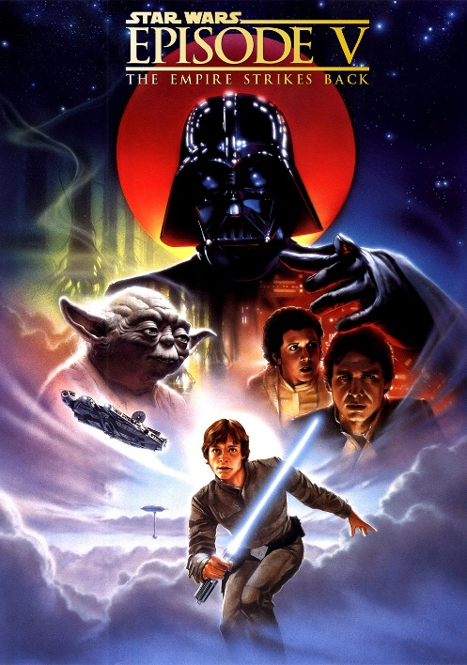
- Science-fiction
Science-fiction is a film genre that lets the plot of the story depend on mathematical and physical sciences. Most of these stories take place in hypothetical and or fictional future. The genre was first introduced in novels from the nineteenth century. Some well-known ones are for example the ones written by Jules Verne. Special effects are very important in science-fiction films because most scenes take place in a fictional world. This world has to be creates using special effects. The style of music used in these kinds of films are mostly futuristic. Examples of science-fiction films are Star Wars: Episode V – The Empire Strikes Back and The Matrix part I. Star Wars: Episode V is about the protagonist Luke Skywalker who is part of a rebel force that tries to overthrow the evil galactic empire. The Matrix part I is about the protagonist Neo who finds out that he and the rest of the world have been living in a computer generated world.
Trailer of Star Wars: Episode V: https://www.youtube.com/watch?v=JNwNXF9Y6kY
Trailer of The Matrix part I: https://www.youtube.com/watch?v=m8e-FF8MsqU
- Fantasy
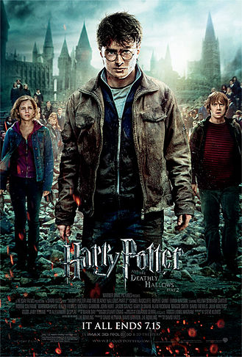
The Fantasy genre can be recognised by the stories which contain imaginary creatures and worlds. The fantasy as we know it today is around 150 years old but uses elements from literature much older. Elements like heroes for example originate from mythological stories from millennia ago. Like in the science-fiction genre the special effects are very important to make the scenery of the story seem realistic. Music used in fantasy films is mostly mystic thus mystifying the scenes. Two examples of fantasy films are Harry Potter and the Half Blood Prince and The Lord of the Rings: The Return of the King. Harry Potter and the Half Blood Prince is about the young wizard Harry who together with his headmaster Albus Dumbledore tries to unravel the secret past of the evil Lord Voldemort. The Lord of the Rings: The Return of the King is about the hobbit Frodo Baggins whose aim is to defeat the evil Lord Sauron.
Trailer of Harry Potter and the Half Blood Prince: https://www.youtube.com/watch?v=jpCPvHJ6p90
Trailer of The Lord of the Ring: The Return of the King: https://www.youtube.com/watch?v=r5X-hFf6Bwo

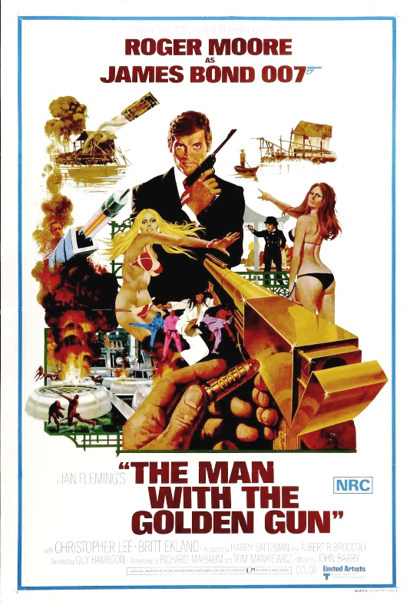
- Action
The action genre is one of the more recent ones. It emerged in the 30s but became incredibly popular with the introduction of the first James Bond movie in 1962. Actions movies can be recognized by the abundance of gunfights, chases and explosions. The music used in action movies is mostly upbeat and used to excite the viewer. Two examples of action films are James Bond: The Man with the Golden Gun and Indiana Jones and the Kingdom of the Crystal Skull. James Bond: The Man with the Golden Gun is a movie about the secret agent James Bond who tries to kill the antagonist Francisco Scaramanga who is also known as the man with the golden gun. Indiana Jones and the Kingdom of the Crystal Skull is a movie about the adventurer Indiana Jones who tries to solve the mystery of the ancient crystal sculls.
Trailer of James Bond: The Man with the Golden Gun: https://www.youtube.com/watch?v=Xzt6zAj7XUM
Trailer of Indiana Jones and the Kingdom of the Crystal Skull: https://www.youtube.com/watch?v=Ibc7Au8SSB0
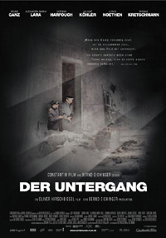
- War movies
The War movies genre mostly features movies which are based on true stories which took place during wars. Tales about wars have always fascinated people so there are a lot of ancient war stories. The music in war movies can be either happy or sad. It all depends on the type of scene.
Two examples of war movies are Der Untergang and Saving Private Ryan. Der Untergang is a movie about the last days of Adolf Hitler’s life inside his bunker in Berlin. Saving Private Ryan is a movie about the brother of three perished soldiers who has to be found during the heat of WWII in France.
Trailer of Der Untergang: https://www.youtube.com/watch?v=Q9pl7IWPx5E
Trailer of Saving Private Ryan: https://www.youtube.com/watch?v=zwhP5b4tD6g

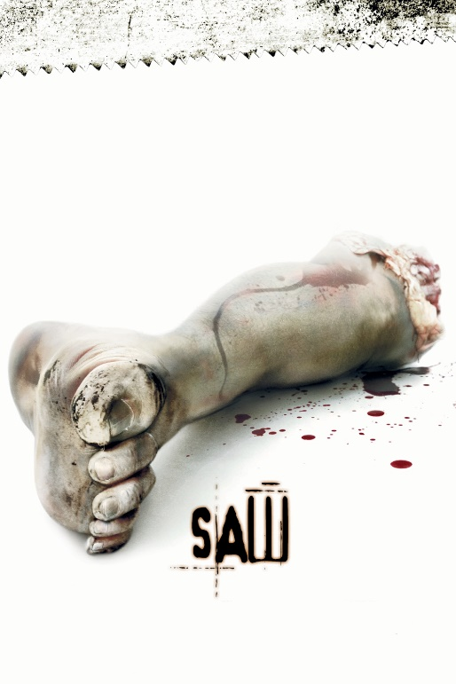
- Horror
The Horror genre features movies in which the main theme is fear. Horror itself is quite an old film genre and started with movies like Frankenstein and Dracula. The main purpose of Horror movies is to frighten the viewer which is partially realised using certain kinds of music and sound effects. Two examples of horror films are Saw I and Insidious. Saw is about two men who were locked up in a room by the infamous Jigsaw-killer. They have to try and escape by way of executing certain tasks set by the Jigsaw-killer. Insidious is a movie about a family who is haunted by spirits after they move to another house. One of the boys doesn’t wake up one morning and it’s believed that he is in a coma but it turns out his soul left his body and he is stuck in The Further.
Trailer of Saw I: https://www.youtube.com/watch?v=HKPy5RWuqNA
Trailer of Insidious: https://www.youtube.com/watch?v=E1YbOMDI59k

