Bungee physics Remy Zoutman Bv6c

The Problem
Bungeejumping is an activity for real daredevils. From great heights you let gravity do its work while a cord, your lifeline, prevents you from smashing into the ground. It is necessary that this cord has the right properties, to ensure the safety of the jumper. Through modulus we have created a model for a bungee cord which ensures maximum safety for its user.

The model
To safeguard the cords we have designed a model which includes the three major forces at play when bungee jumping: Gravity, air resistance and elasticity. The model has been programmed to exclude elasticity up to 40 meters, since the cord is 40 meters long. As you can see the constant in Fveer is negative, since this force opposes the gravity, the same counts for the Fwl.
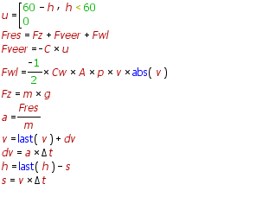


Several starting values have been used to ensure the safety of a variety of different jumpers, weight and the thrill factor have been taken into consideration.
First of all there is a spring constant (Hook’s law) of 65 N/M This number has been chosen since it allows variety in bungee jumper mass whilst least restricting the length of the free fall.
It also ensures safe g-force values, as the maximum g-force experienced increases with weight. Thus there is a weight limit capped at 100 kg.

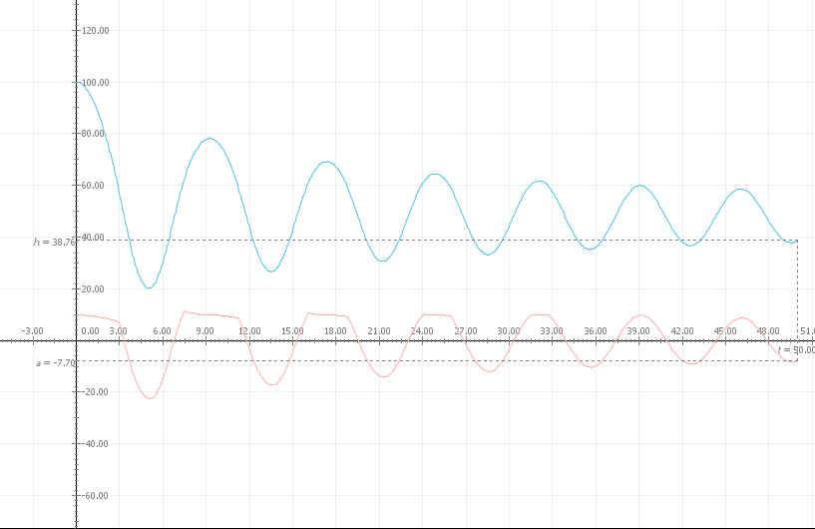
As seen in this graph the height of a 80kg person will not get lower than 20m from ground lever, his maximal acceleration is 22 m/s^2

Should the need arise to increase the thrill factor, it can be done by increasing the spring constant, but at the cost of jump height, since the cord will be sprung much more tightly. C=f/u so an increased c means more force for each meter of stretch. Decreasing the factor will lead to dangerously low jumps which can result in lethal trauma! It is strongly recommended to not engage such activities!

Result
It is safe to assume that whilst conforming to this model, the bungee jumper will have a minimal risk of hitting the ground or of being exposed to too much g-force. The safety is guaranteed for all persons with a weight below 100kg so m<100, in conjunction with a spring constant of 65N/m.

Appendix

The acceleration and height of a 100kg jump. As seen here the person will still be 10m above ground level and have a max acceleration of +/- 20 m/s^2 with a C=65 N/m
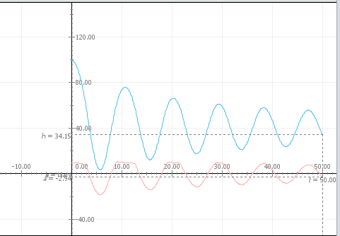
Figuur 1

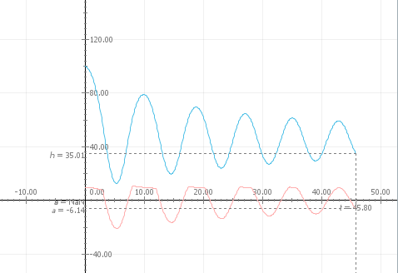
Figuur 2
Lowering the spring constant to 50 N/m already poses major risks for heavy persons! It may lead to possible death!

See appendix figure 1
See appendix figure 2

