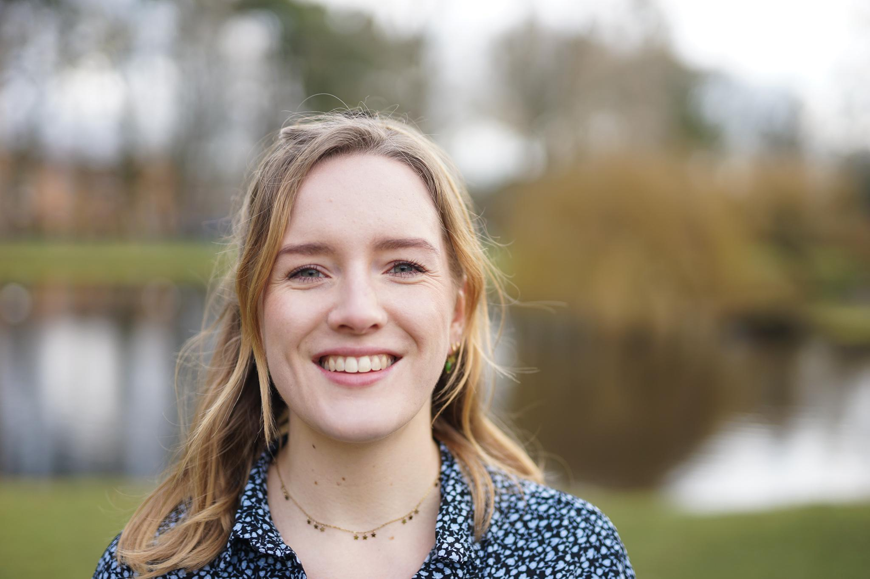

EVA KLAVER

Date of birth: 7-10-1998
Place of birth: Blaricum
Nationality: Dutch

Address: Ina Boudier-Bakkerlaan 147
3582 XX, Utrecht

evaklaverr@gmail.com

+31655517608

EDUCATION
PRE-UNIVERSITY EDUCATION
09/2010 – 05/2016
Berger Scholengemeenschap

BACHELOR CHEMISTRY
MINOR ENTREPRENEURSHIP
09/2016 – 12/2020
Utrecht University

WORK HISTORY
STUDENT EMPLOYEE
11/2016 – PRESENT
Utrecht University
Informing and helping high school students with open days.

STUDENT TUTOR, COORDINATOR
10/2018 – 09/2019
Utrecht University
First point of contact for first year students, giving information and advice about their studies. Besides, coordinator of all student tutors.

CHAIRMAN OF UNIVERSITY COUNCIL
PARTY DE VRIJE STUDENT, PR COMMISSIONER (FULLTIME)
09/2019 – 09/2020
Universiteit Utrecht
Member of the University Council, responsible for the course and standpoints of the party De Vrije Student and responsible for communication to the rest of the party. Besides, responsible for the PR of the University Council.

extracurricular activities
MEMBER STUDENT COUNCIL
12/2011 – 05/2016
Berger Scholengemeenschap
Representing the interests of pre-university students towards the Board at the high school.
EDITOR SCHOOL PAPER
05/2013 – 06/2015
Berger Scholengemeenschap
Writing articles for the school paper.
HEAD EDITOR SCHOOL PAPER
06/2015 – 05/2016
Berger Scholengemeenschap
Leading the meetings of the school paper, writing articles and controlling the work handed in by other members.
#2 ON THE LIST FOR THE UNIVERSITY COUNCIL PARTY
DE VRIJE STUDENT
03/2018 – 03/2019
Universiteit Utrecht
Co-responsible for the campaign, writing the election programme and recruiting candidates.

MEMBER YEARBOOK COMMISSION, COMMISSIONER ACQUISITION (FULLTIME)
05/2018 – 12/2018
C.S. Veritas
Creating the yearbook, making deals with companies to raise money to finance the yearbook.

extracurricular activities
BOARD MEMBER, SECRETARY
09/2018 – 09/2019
JOVD Utrecht e.o.
Responsible for recording meetings, in- and outcoming e-mails, social media and the website.

#1 ON THE LIST FOR THE UNIVERSITY COUNCIL PARTY
DE VRIJE STUDENT
02/2019 – 04/2020
Universiteit Utrecht
Responsible for the campaign, writing the election programme and recruiting candidates.

FOUNDER, CHAIRMAN
06/2020 – PRESENT
ModernGroen
Founder of the political think tank ModernGroen, together with Sander Bosman. Our goal is to find the connection between sustainability and prosperity.
- www.moderngroen.nl -

BOARD MEMBER, GENERAL
09/2020 – 03/2021
De Vrije Student Utrecht
Part of the board, having an advisory role towards the board.

BOARD MEMBER, INTERNAL RELATIONS
03/2021 – PRESENT
De Vrije Student (national)
Responsible for maintaining and improving the relationships between and inside different networks of De Vrije Student. Giving advice to the board.

