YOUTUBE LINGO EXPOSED (GONE WRONG)?!
By Robin Wacanno
Language is all around us, even here on the internet. Language is also shaped by its users. In the case of internet language, it’s shaped by us, the surfers on the world-wide web. Recently a video was posted on the PBS Idea Channel on YouTube. In this video the host discusses several ‘dialects’ used among different internet communities. The weird thing is however, especially since the video was posted on YouTube, he didn’t discuss the ‘dialect’ used on YouTube. That’s why I have taken this burden upon myself and will be teaching you the important aspects of the YouTubian dialect in this blogpost.

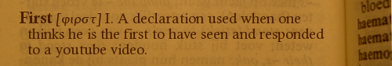
I found it fitting to start this lesson off with the word “First”. This is a declaration used in the YouTube comment section. In most cases “First” is short for: “Hey there, I was so quick with clicking on this recently released video, it enabled me to leave the first comment.” Leaving such a comment became quite a hype a few years ago, when viewers wanted to show their dedication to certain popular youtubers (people who create video’s). Now however the practice is usually frowned upon so I would not encourage you to use it. From “First”, a few spin-offs were created over the years. Examples of these are the obsolete “Under 301 club” and the more recent “Notification squad”. The first (no pun intended) one of these examples was used when the view-counter of a YouTube video would display the number 301 for a while after it had reached this amount of views. The second example has been gaining popularity since viewers have been able to receive notifications on their phone when certain YouTube channels post a new video. Both however, serve the same purpose as “First”

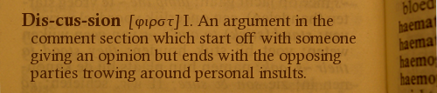
The YouTube comment section is, in contrast to the earlier mentioned abuse, also used to have discussions. Although you might think these discussions are about the contents of the video in question, this is often not the case. There are a few things you should know about discussions on YouTube: they should only loosely be based on the contents of the video; arguments used during the argument should not be from reputable sources, in fact, they should be based on your ‘feelings’ and, most importantly, every discussion should get personal.
A good example of the first aspect mentioned can be found in the following comment:
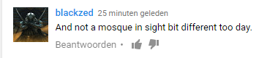
This comment was left beneath a video in the British Pathé channel. The video itself was about Dutch royalty, but apparently, this viewer found it appropriate to comment on the fact that there are too many mosques in The Netherlands. Nowhere in the video the word mosque was mentioned nor were at any time visible. Since then, the comment has been deleted indicating the commenter concluded his comment was completely irrelevant and inappropriate as well. Luckily, I took a screenshot of the comment before it was deleted :P.
An example of the personal aspect of discussions can be seen in the following comment:
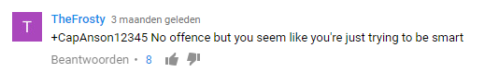
This comment was left under a video about the tax plans of Trump and Clinton and I think it speaks for itself.

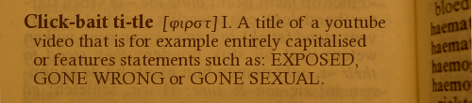
An important aspect of every YouTube video is the title. It is, together with the thumbnail, the metaphorical cover of a YouTube video. That’s why it’s important to give your video an interesting and catchy title so more people want to watch your video. A few youtubers however, seem to be a bit too enthusiastic when coming up with titles for their video’s. They use some less subtle techniques to make their video’s look interesting. One of the most prominent techniques used in video titles in the full capitalization. Here is a title I’ve picked randomly from the Trending page on YouTube which show the use of this technique nicely:
The full capitalization of words you want to emphasize can be a very effective tool but by capitalizing every word in the title it just loses any meaning. When reading these kinds of titles, it’s just as if someone is continually screaming in your ear trying to get your attention. Judging from the view counts of these video’s however the technique still has the desired effect.
Another frequently used technique is the inclusion of certain buzz words or phrases in your title. Words and phrases such as EXPOSED of GONE WRONG seem to be some of the more popular variety.
EXPOSED usually implies the video will reveal some negative information about something or someone. Youtubers mostly make these videos about fellow and/or competing youtubers. When this results in a fight between two youtubers and their respective fanbases, it’s commonly called YouTube Drama. While Youtube Drama might seem unfavourable it’s the complete opposite of that, since the attention channels get due to Drama usually yields quite a number of views for both parties.
GONE WRONG is included in a video title when the creator wants to stress that the video shows something which did not go as planned. In recent years, the site has been oversaturated with video’s using this phrase in their title which has resulted in the phrase having lost its effectiveness.
Nowadays, most popular youtubers use the above-mentioned techniques for comedic effect only since earnestly using them will make frequent YouTube viewers not take your video’s serious.

In the end, this post was just an attempt to describe the way the users of YouTube have shaped the language used on the site. While the use of the above-mentioned language is popular, it should in my opinion not be used. I encourage you, the reader, to leave a reaction giving your opinion on this language and maybe examples I haven’t covered.

[Sources]
http://www.dailydot.com/parsec/dialects-of-internet-communities/
https://www.youtube.com/watch?v=SDPasRas5u0

For certain keywords:
http://knowyourmeme.com/
http://www.urbandictionary.com/

For the comments and title:
https://www.youtube.com/watch?v=csLiYr5OGbg
https://www.youtube.com/watch?v=ygsLQW94-UM
https://www.youtube.com/watch?v=SgicDQHbV3M

