Faculty of Science on Insta and Twitter: UvA_science
To Dah Loo – Published by the Faculty of Science in cooperation with the student council
QR code: Todahloo online archive

----------------------------------------------------------------------------------------------------------------

[FSR-stijl] The Faculty Student Council:

We hope you are enjoying these hot days before the summer as much as we are! Although it’s hard to remain focused during the final stages of the year, we wish you the best of luck with the last mile before the summer holidays. We want to take this opportunity to look at the future of Science Park. We have been working hard on our proposals for next year’s teaching- and examination regulations (OER) to make studying here more pleasant for you. Therefore, we advised the faculty board to include compulsory attendance in the study guide. This way, students will know if attendance is mandatory for lectures and tutorials before they register for a course. Furthermore, we are proposing that students who take a resit receive more guidance in the period between their exam and their resit. We also hope that it is made mandatory for course evaluation results to be published, so students can see if their feedback is considered.

In addition to looking forward, the student council wants looks back: after a fruitful year of discussing policies and working on new initiatives, it is time for us to pass the baton to a new council. After two years of writing this column, it feels weird to say goodbye to you all. We hope you’ll enjoy these monthly updates by our successors just as much! Make sure to relax and enjoy yourself during the summer, it’s well deserved after this hard year. For the last time and with the best wishes for next year:
Kind regards,

Daan Jellema and Koen Oostinga
The Faculty Student Council FNWI 21/22

[footer]
More information? Send an email to fnwi@studentenraad.nl or visit us in B0.112.

----------------------------------------------------------------------------------------------------------------

Dear To Dah Loo reader,

I know extremely little about you. I haven’t the slightest clue as to where you were born,
your study, job or other daily activities, your favorite food or artist, or about your hopes,
dreams and ambitions. However, there is one thing that I know absolutely certain about
you. By virtue of you reading this paper right now, I can deduce that you are sitting on a
toilet. Now don’t get embarrassed! Because I’ll share a little secret with you as well, dear
reader. I am also sitting on a toilet right now. Yes, you read that right. I took my laptop to
the bathroom in the Science Park 904 building (the one next to the cafeteria), sat down on
the Loo, and wrote this little piece. Which puts us in quite a special position. I have
personally never talked to a complete stranger while sitting on the toilet. I don’t know how
you feel right now, but to me, it almost feels intimate in a sense. But let’s not make this
weird now. I’ve always seen the science park toilets as a place to rest and reflect, and more
importantly, to take a break from all the scientific stuff that I am usually busy with at science
park. This place is somewhat of an oasis of calmness to me. I hope that, by writing this
piece, I have been able to somewhat bring across that feeling to you. Have a good day, and
good luck with your business at science park.

Cheers,
A fellow Science park toilet-goer
----------------------------------------------------------------------------------------------------------------

Take an interdisciplinary elective in the upcoming semester

[Mocht het qua opmaak beter zijn, dan is er ook een portret versie van de afbeelding beschikbaar, zie mail bijlage]

With the current war in Ukraine, has the Cold War ended at all? What role do science and technology play in the pursuit of happiness? What is needed to boost the transition to a circular economy? In what ways do digital transformations reduce - or exacerbate - social inequality?

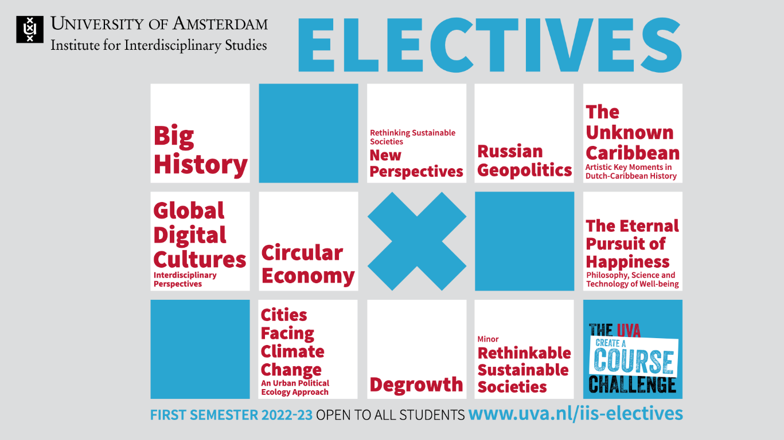
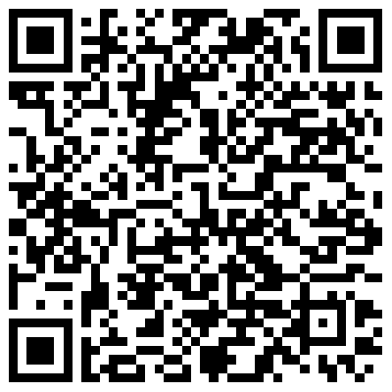
Dive into current events and take an elective at the Institute for Interdisciplinary Studies in the first semester of '22-'23. The new course listing is online now, registration starts on June 13.
----------------------------------------------------------------------------------------------------------------

Opening hours during summer

Check student.uva.nl and the screens in the halls for up-to-date information about opening hours of the library, restaurant and coffee bar, buildings and study centre.
----------------------------------------------------------------------------------------------------------------

Flux festival

To celebrate the summer, study associations of the Faculty of Science organise the Flux Festival on the last education day of the academic year, at 1 July. The study associations have the following fun activities planned:

ACD
Obstacle course
Laser gaming
BBQ

Congo
Belly slide
BBQ
Cocktail bar

GAOS
Painting on a big canvas and painting bikes
Face painting
Picknick met drinks and snacks

NSA
Inflatable swimming pool
Inflatable obstacle course
Belly slide
BBQ

Spectrum
BBQ
Cocktail bar

VIA
Silent disco
Bouncy castle
Food court
Relax area

----------------------------------------------------------------------------------------------------------------
Wanted: TA’s Digital Expertise/Programming for new BSc Computational Social Science

Are you passionate about programming and anything related to digital technology? Would you like to help teach first year students the basics and advanced applications of Python? The new Bachelor's programme Computational Social Science is looking for a whole new team of Teaching Assistants and you may just be one of them! Apply before 24 June.

[QR-link] https://student.uva.nl/en/shared/studentensites/fnwi/fnwi-gedeelde-content/en/news/2022/05/call-for-tas-digital-expertise-cssci.html?origin=%2FEeBVW1XQvCpEO2ebSRf6A

